|  |
| --- |
| 新东方在线英语学习 |
| 新概念 2 册 |
| Lesson69 |



扫一扫。更多有趣的英语资讯。

# Lesson 69 单词讲解

1. instruct v. 命令，指示 instruct sb to do sth. instruction n. 指导，说明 follow the instruction
2. confidence n. 信心confident adj. 有信心的self-confidence n. 自信心

self-confident adj. 有自信心的

1. examiner n. 主考人

examine v. 检查

examination n. 检查，考试 ( exam )

1. suppose v. 假设
2. Let us suppose that …
3. be supposed to do 应该做某事

You are supposed to tell me what to do. She is not supposed to be here.

murder ['mə:də] n.谋杀

2 instruct[in'strʌkt] v.命令，指示

3 acquire[ə'kwaiə] v.取得，获得

4 confidence ['kɔnfidəns] n.信心

5 examiner [ig'zæminə] n.主考人

6 suppose [sə'pəuz] v.假设

7 tap [tæp] v.轻敲

8 react [ri'ækt] v.反应

9 brake [breik] n.刹车

10 pedal ['pedəl] n.踏板

11 mournful ['mɔ:nful] a.悲哀的

Key points:

# Lesson 69 课文&语法讲解

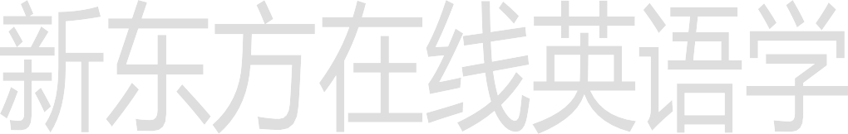

复习被动语态

非谓语动词

having been done

1. I was being tested for a driving licence ...
2. I had been asked to drive in heavy traffic ... be done 过去完成时的被动

被动语态

for the third time 第三次

1. After having been instructed to drive out of town, I began to ... having been done

非谓语动词

表示被动，发生在先

been instructed 是被动，having 是因为这个事情发生在前，所以应该是完成时had，但是这个句子已经有了谓语 所以改成ing形式

非谓语动词表示被动

Beaten by a girl, the boy cried. (done)

详见L49 现在分词做状语 其实就是状语从句的省略

Having been beaten by a girl, the boy cried. (having been done)

Being beaten by a girl, the boy cried. (being done)

详见L49 现在分词做状语 其实就是状语从句的省略

having been done 练习：

已经被告诉了很多次，他还是犯相同的错误。

Having been told many times, he still repeated the same mistake.

he still 一主一谓已经搭配好了，所以前面的句子得改成非谓语

having been done 练习：

被广告影响之后，人们就会冲去买一种新产品。

Having been influenced by the advertisements, people will rush to buy a kind of new product.

1. The examiner must have been pleased with my performance, for he smiled ...

must have been 过去的推测

must have done 推测过去

1. ‘… Let us suppose that a child suddenly crosses the road in front of you…

crosses the road 过马路 in front of you 在。。前面

1. Though the sound could be heard clearly, it took me a long time to react. It takes sb. ＋时间＋to do sth.

It took me ten minutes to persuade her … L54

1. I suddenly pressed … and we were both thrown forward.

in a mournful voice 用。。。声音

# Lesson 69 知识拓展

What are you doing out of bed, Tom? You’re to be asleep.

* 1. supposed
  2. known
  3. thought
  4. considered (2011 辽宁 22)

What are you doing out of bed, Tom? You’re to be asleep.

1. supposed
2. known
3. thought
4. considered (2011 辽宁 22)



非谓语动词 表示被动

Beaten by a girl, the boy cried. (done)

Having been beaten by a girl, the boy cried.

(having been done)

Being beaten by a girl, the boy cried. (being done)

around the Water Cube, we were then taken to see the Bird’s Nest for the 2008 Olympic Games.

1. Having shown
2. To be shown
3. Having been shown
4. To show (2008 陕西 14)

around the Water Cube, we were then taken to see the Bird’s Nest for the 2008 Olympic Games.

1. Having shown
2. To be shown
3. Having been shown
4. To show (2008 陕西 14) 补充：

having done

Having finished his homework, he then watched TV.

非谓语动词 主语 谓语表示：主动，发生在先

having been done

非谓语动词

表示：被动，发生在先

around the Water Cube, we were then taken to see the Bird’s Nest for the 2008 Olympic Games.

1. Having shown
2. To be shown
3. Having been shown
4. To show (2008 陕西 14)

around the Water Cube, we were then taken to see the Bird’s Nest for the 2008 Olympic Games.

1. Having shown
2. To be shown
3. Having been shown
4. To show (2008 陕西 14)

The trees in the storm have been moved off the road.

1. being blown down
2. blown down
3. blowing down
4. to blow down (2008 湖南 26)

The trees in the storm have been moved off the road.

1. being blown down
2. blown down
3. blowing down
4. to blow down
5. having been blown down (2008 湖南 26)